Extreme Java

Lab Guide

Written By: Rony Keren
Internet Team
John Bryce training center

Lab 01 – Custom class loader

In this exercise you are about to implement a Network Class Loader.
The class loader takes a string that represents the desired class and returns a byte representation of it. If the class is not available [means that it is not located directly under the root directory of the server] than a null value is returned.
- Since the server is fully implemented, you should focus on the RemoteClassLoader that resides at client side, located under labs\lab01\exercise\client and add the appropriate code to the findClass() method for it to be capable of doing the following:
- Note that the constructor already takes host & port
- Generate a socket to connect to the server
- Obtain the socket output stream as DataOutputStream and send the given class name via writeUTF() method
- Obtain the socket input stream as ObjectInputStream and read the class byte array (byte[]) via readObject() method
- Throw NoClassDefFoundError if the server returned null
- Convert the byte array into a Class via defineClass() ClassLoader method
- Explore the remote class you are about to load named ‘RemoteClass’– it is located under labs\lab01\exercise\server
Note that this class is not part of your client project and that your instance of VM has no way of loading it via default class loaders
- Launch the server that serves class binaries by clicking the ‘startServer.bat’ located under labs\lab01\exercise\server
- Run the Test class that uses your RemoteClassLoader to load a class located on server side & named “RemoteClass”
- Note that if you change the class name to load in Test.main to any other customized class it fails as expected – but if you send one of the core objects such as ‘java.lang.String’ – all works well. Why ?

Lab 02 – Collections

In this exercise you are about to use a collection for word counting.
The program will load a file and store in the appropriate collection a list of the words exists in the file and how many times each appears.
The result of the program will be a print of all words but in two different orders in two different prints:
- Natural order (A-Z)
- Length
In order to do so, a Comparable class Word is provided which provides the following:
- Constructor that takes the word in a String format & wraps it
- toString() that returns the wrapped word as a String
- equals() & hashCode() that implemented to compare objects of type Word according to their wrapped string values
- compareTo() that adapts java.lang.String behavior
- You may simply use java.lang.String instead – they are pretty alike for this lab
In order to complete the exercise follows these instructions:
- Choose the appropriate type-safe collection. Don’t forget you have a word and a number of appearances at each entry. Also note that Word class have a natural order support which is based on java.lang.String so you can use a sorted collection for the first print.
- Edit the WordCounter main method located under labs\lab02\exercise\
- Load the file ‘text.txt’ provided in this lab via FileReader
- Iterate the file to load each word to memory (you can use BufferedReader in order to load one line at a time, and StringTokenizer in order to parse the line into single strings)
- Calculate each word appearance time and update the collection respectively.
- For the first print – if your collection is a sorted one, simply use the toString() of it.
- In order to sort according to the word length – complete the code in the LetterCountComperator class and override the compare() method to do the calculation. You may leave the equals() method to be inherited from java.lang.Object
- Re-sort your collection using the LetterCountComperator and print the new sorted collection

Lab 03 – Threads

In this exercise you are about to use the entire multitasking system capabilities and also experience the Executor API
Phase 1:
- In this phase you will define an ArrayList based stack which is
  - Naturally not thread-safe
  - Have unlimited amount of elements but cannot manage a negative index
- Then you will create a producer that puts values in the stack & a consumer that polls values
- Your main class will create 2 producers and 2 consumers and make them work a single stack instance simultaneously
- In order to complete this phase follow these steps:
- Move to labs\lab 3\Phase1\exercise
- Edit the Stack class
  - pop() method pops a value from the stack. Therefore should be thread-safe. It also must block a consumer if the stack is empty, print out the taken value and the consumer thread name
  - push() method takes an int and adds it to the stack. Therefore should be thread safe. It also releases the stacked consumer threads and prints out the inserted value and the producer thread name who puts it
- Edit the Producer class
  - To be Runnable
  - Implement run() method to push 20 int values to the stack and sleep a random amount of ms between insertions

- Edit the Consumer class
  - To be Runnable
  - Implement run() method to pop 20 int values from the stack and sleep a random amount of ms between removals
- The main method is fully implemented in the Factory class
  - Explore the way a stack, producer & consumer are instantiated
  - Examine how 4 different threads takes the producer and consumer and executes them simultaneously
- Launch the application form Factory class
  - Examine the output
  - When threads gets blocked ?

Phase 2:
- In this phase you will transform the previous lab to work with Executor and Callable classes
- In order to complete this phase follow these steps:
  - Leave Stack class unchanged
  - Producer class
    - Turn it into a Callable<Integer> (means that the call() method returns an in value – 0=OK, 1=Failure)
    - Implement the call() method to act just like the Producer.run() method. In case of throwing exception – catch it and return 1. If everything works well return 0.
  - Consumer class
    - Turn it into a Callable<Integer> (means that the call() method returns an in value – 0=OK, 1=Failure)
    - Implement the call() method to act just like the Consumer.run() method. In case of throwing exception – catch it and return 1. If everything works well return 0.

  - Factory class main method
    - Create a cached thread pool via Executors class
    - Instantiate 4 callable objects – 2 of type Producer & 2 of type Consumer
    - Create a type safe collection that hosts those Callable [Collection<Callable<Integer>>] and add all four instances to it
    - Use the cached thread pool executor to launch all the Callable that are in the collection. No needs to process return values.
    - Shutdown the executor so it will not accept any new tasks and exit once all Callable objects ends
  - Launch the application form Factory class
    - Examine the output
    - Replace the cached thread pool with fixed thread pool with 2 threads only
    - Launch the application again and examine the output

Lab 04 – Threads – Fork-Join

In this exercise you are about to use fork join in order to collect file list from your FS with a given extension.
For example, user wants to get a file list of all the *.exe in a specific location – so he can use your application and assign the following:
- File extension (exe)
- Location to start from (directory, path)

Follow these steps in order to complete this exercise:
Files are located at labs\lab4\exercise
- In class DirectorySearch, which is your recursive task, you get 3 arguments in the constructor. This part is already provided:
  - directory : String – location where the search starts
  - fileExt : String – file extension to seek
  - fileList : Collection<String> - a shared collection to gather all file paths found during the search.
The task must start the search in 'directory'.
- Implement the search in compute() to scan all files in the given
'directory'

For each sub-directory –create a sub-task and put it in a sub-task
collection.
Each sub task is instantiated with the same 'fileExt' and 'fileList'
but with the current 'sub-directory' before being added to the sub-
task collection.

For each matching file found –report by adding it to 'fileList' which is shared by all tasks (& sub tasks)

By the end of the search in the specific directory you'll have several
sub-task for each sub-directory – now it is time to launch them as
well via invokeAll() method

- Run class already knows how to get from user input the directory and file extension in order to start the search and also already generates an instance of your first in hierarchy task – DirectorySearch. All you have to do is to fork it via ForkJoinPool, and print all founded files (placed in the shared Vector) after search ends

Lab 05 – Reflection

In this exercise you will use reflection in order to instantiate objects via XML metadata
The XML specifies the class name to instantiate and provides information regarding the types and values that should be assigned to it if there is no default constructor.
The supported XML format is specified in the following DTD:

<!DOCTYPE class [
<!ELEMENT class (param*)>
<!ATTLIST class name CDATA #REQUIRED>
<!ELEMENT param ( #PCDATA | class )*>
<!ATTLIST param type (int|short|byte|boolean|long|float|double|string|object) #REQUIRED>
]>

Note that this Meta data support only primitives and objects as initiation parameters – no annotations, interfaces and Enums.
An XML implementation is also provided along with an ExampleClass that has the following constructor:

public ExampleClass (String value,Date date, int num){
this.value=value;
this.date=date;
this.num=num;
}

The XML contains all required information for instantiating this class named class.xml and is also provided and looks like that:

<class name="ExampleClass">
<param type="string">Hello !!!</param>
<param type="object">
<class name="java.util.Date">
<param type="int">12</param>
<param type="int">5</param>
<param type="int">1</param>
</class>
</param>
<param type="int">300</param>
</class>

Your mission is to code the Loader class that uses reflection and Meta data to create objects. The files, including XML, are located at
labs\lab 4\exercise
The Loader class takes the XML location as a string when created.
The constructor that loads the XML is provided.
The method load(), also provided, starts the loading process by getting the top level <class> element, which specifies the class that must be returned eventually as an instance. This method uses the instantiate(Element class) method – and here comes your part.
In order to implement the instantiate(Element class) method follow these steps:
- The method takes a DOM element as an input parameters. The element represents the <class> tag that may hold a list of constructor parameters in a group of <param> tags.
First, you have to obtain this list as NodeList via DOM.
- If there is no list – it means that the default constructor can be used to instantiate the class with the given name (specified under the class name attribute and already obtained in the provided code) – use reflection to do it.
- If there are parameters, scan the list and do the following for each param:
  - Get its value and put it in the Object[] param array. Remember to convert it to the specified type – don’t store it in a string format unless the type of it is ‘string’
  - Get its type and put the type class [for example: int type will be stored as int.class] in the Object[] objectParam array.
Note: in case that one of the constructor parameter is an object – the initiation should be done recursively.
- After loading all values and types to the two correlated arrays, use the objectParam array to track the right constructor from the requested class and use the param array to instantiate an object all done via reflection API
- To launch and test your implementation simply run LoadClass.main() which is also provided. Note that it assumes the XML is placed directly under C: and that it tries to fetch an instance of ExampleClass in order to use its toString() method.
- You can now create your own XMLs and use them to instantiate other objects.

Lab 06 – New I/O

In this exercise you will use I/O between two threads. In order to do so you will use the Pipe class. This class receives and assigns data buffers and acts like an asynchronous queue. The thread that puts the buffer doesn’t have to interact with the thread that loads it directly.
In this lab we will create two Runnable classes – one to write to the pipe in one to read from it. The data transferring between the threads , in this lab, will be in int format.
In order to complete the task, follow the next steps:
- Edit the classes located under labs\lab 5\exercise
  - WriteToPipe class
    - Edit the constructor to get the SinkChannel form the Pipe, which is the input parameter, and store it in a compliant data member. This sink channel will host all data sent to the pipe.
    - In run() method:
    - Create a byte buffer with the size of 160 bytes
    - Convert it to an int buffer. The reason for doing so, instead of creating just the IntBuffer via its static allocate() method is that Pipe takes ByteBuffers
    - Put around 40 small numbers (between 0-40) in the int buffer
    - Upload the data to the pipe via SinkChannel.write()
  - ReadFromPipe class
    - Edit the constructor to get the SourceChannel form the Pipe, which is the input parameter, and store it in a compliant data member. This source channel will receive the data from the pipe.
    - In run() method:
    - Create a byte buffer with the size of 160
    - Read the data from the source into the buffer
    - In order to view the int values that are now in your byte data run over the buffer and use the getInt(index) method. Note – you are iterating a Byte buffer and read int values which means your index should be raised by 4 for each ‘get’ operation.
  - ChannelExample class
- Here all you have to do is simply instantiate a Pipe via SelectorProvider in the provided main method
- Examine the method to see how two threads are created and started while referencing to the same pipe instance
- Run the code

Lab 07 – Internationalization

In this exercise you will turn a non locale-sensitive UI to support two locales.
The given situation is a non locale-sensitive form approval screen specified in BadUI.java file located at labs\lab 6\exercise that uses hardcoded English strings.
The class displays a form approval screen after the client has chosen an item and the number of units he would like to buy.
The form displays the customer’s choice, time & date, unit price & total price.
Here’s a detailed list of the presentation fragments included in the form approval screen:

Title – ‘Order Details’

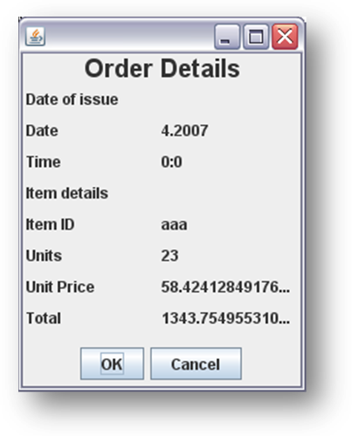
Date message – ‘Date of issue’
Date title – ‘Date’
Date value - [a date value in short format]
Time title – ‘Time‘
Time value – [a time value]

Order message – ‘Item details’
Item message – ‘Item ID’
Item value
Units message – ‘Units’
Units value – [a number]
Unit price message – ‘Unit Price’
Unit price value – [a currency]
Total message – ‘Total’
Total value – [a currency]

OK button label – ‘OK’
Cancel button label – ‘Cancel’

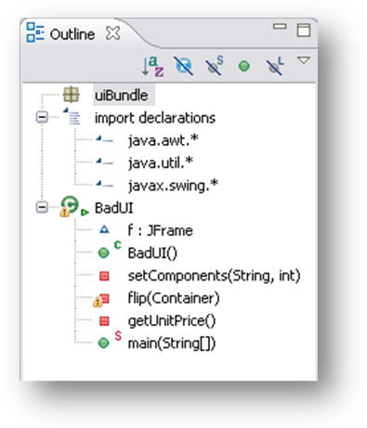
The class outlines:
- Package & Imports
- Class – BadUI
- Constructor
  - Takes no arguments
  - Calls the method that place components
  - Sends a default item ID & units [“aaa”,23]
  - You don’t need to edit it
- setComponents(String,int)
  - Is the method that does a lousy job
  - Adds all UI components to the form
  - Uses English hardcoded texts and formats
  - You should edit this method to use your bundles
  - In order to make things easier to track – every non locale-sensitive injection to the screen is marked with a single line comment “not locale sensitive !”
- flip()
  - Is a methods that helps in mirroring the view
  - Useful when moving to right to left languages
  - You don’t need to edit this method
  - You may use it for the Hebrew view by simply calling it before ‘setComponents’ returns
- getUnitPrice()
  - a private method that returns a random value as the unit price
  - you don’t need to edit this method
  - you will have to format its value before presenting it

You need do the following:
- export all hardcoded string and non-formatted values to a default resource bundle class, this will be your base class
  - Class name <base resource name>.java
- create another resource bundle class to support Hebrew
  - Locale – “iw_IL”
  - Class name - <base resource name>_iw_IL.java
- Edit the BadUI.setComponents(..) method to use bundles in order to place labels text and format values

After completing the assignment the view should support two locales
- “en_US”
- “iw_IL”
And look like this:

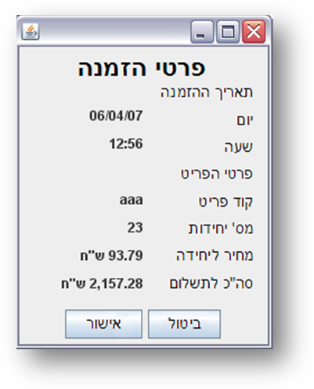
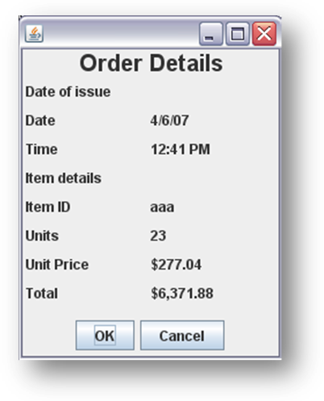

Lab 08 – Effective Java

In this exercise you will create your own version that does exactly what an existing code does – but this time – much better.
The lab consists of bad and good packages. Both packages holds classes that should do the same business logic:
bad.BadImplementation
bad.Person
good.GoodImplementation
good.Person
Your job is to fill the good.GoodImplementation class so it will follow the same logic as implemented in bad.BadImplementation and change few things in good.Person class which is also currently a copy of the bad.Person class.
Both classes are located at labs\lab 7\exercise
- Feature Envy , Inline, Calling methods within a loop – Currently, occurs every time the private method good.GoodImplementation.printData() points to a Person instance and calls its get() methods. It means that :
  - the caller is tightly coupled with the Person class
  - a lot of methods are invoked within the loop in the good.GoodImplementation.print()
- Update the good.Person class to have a toString() method to return in a single line all that data
- Update good.GoodImplementation.print() to use Person.toString()
- Intensive string concat - good.GoodImplementation.print() uses string concat which causes a huge amount of objects to be generated during runtime
- Update - good.GoodImplementation.print() method to use StringBuffer
- Now, apply the required changes in order to enhance the good.GoodImplementation.printYoungest() method
- In order to view results and measure performance improvements, a test application is fully provided – Test.class that does the following for both bad and good implementations:
  - Creates and instantiates a Person array with the size of 20
  - Instantiates the implementation classes (BadImplementation & GoodImplementation) with the Person array
  - Keeps a start time
  - Invokes both print() & printYoungest() methods from the implementation classes a 100 times (!)
  - Calculates the duration of the operation in ms and prints it
This is done for the bad implementation via testBad() method and for good implementation via testGood(). The main() method calls both so you can get a clear picture of the differences between the two.

